PROJECT REPORT

TOPIC:

PREDICTING LIFE EXPECTANCY USING MACHINE LEARNING

BY:ADITI GADEWAR

*INTRODUCTION:*

**OVERVIEW:**

A typical Regression Machine Learning project leverages

historical data to predict insights into the future. This

problem statement is aimed at predicting Life Expectancy

rate of a country given various features. Life expectancy is a

statistical measure of the average time a human being is

expected to live, Life expectancy depends on various

factors: Regional variations, Economic Circumstances, Sex

Differences, Mental Illnesses, Physical Illnesses, Education,

Year of their birth and other demographic factors. This

problem statement provides a way to predict average life

expectancy of people living in a country when various

factors such as year, GDP, education, alcohol intake of

people in the country, expenditure on healthcare system

and some specific disease related deaths that happened in

the country are given.

**PURPOSE:**

Life expectancy is a statistical measure of the average time

a human being is expected to live, Life expectancy depends

on various factors: Regional variations, Economic

Circumstances, Sex Differences, Mental Illnesses, Physical

Illnesses, Education, Year of their birth and other

demographic factors.

This problem statement provides a way to predict average

life expectancy of people living in a country when various factors such as year, GDP, education, alcohol intake of

people in the country, expenditure on healthcare system

and some specific disease related deaths that happened in

the country are given.

**LITERATURE SURVEY**

**Existing Problem:**

This problem statement provides a way to predict average

life expectancy of people living in a country when various

factors such as year, GDP, education, alcohol intake of

people in the country, expenditure on healthcare system

and some specific disease related deaths that happened in

the country are given.

Life expectancy is a statistical measure of the average time

a human being is expected to live, Life expectancy depends

on various factors: Regional variations, Economic

Circumstances, Sex Differences, Mental Illnesses, Physical

Illnesses, Education, Year of their birth and other

demographic factors.

**Proposed Solution:**

Designed a Model to predict Life Expectancy on

some features such as year, GDP, education, alcohol intake,

expenditure, disease related deaths in any country

**THEORITICAL ANALYSIS**

**BLOCK DIAGRAM:**

DEPLOYMENT OF THE MODEL

RE-TRAINING THE ML MODEL

EVALUATION OF DATA

TRAINING THE ML MODEL

PREPARATION OF DATA

INSERTION OF DATA

**HARDWARE REQUIREMENTS:**

Processor*:* i3 7th gen or higher

Speed:2GHz or more

Hard disk space: 10GB or more

Ram Memory: 4 GB or more

**SOFTWARE REQUIREMENTS:**

IBM Cloud, IBM WatsonStudio,Python.

**EXPERIMENTAL INVESTIGATION**

**1)Choose a Project :**

Predicting Life Expectancy of a person

**2)Collection of Dataset :**

**3)Hypothesis :**

Based on our study and information gathered we can

predict the average age of a person.

**4)Design :**

Construct various Machine Learning Models and finally

selecting the model with maximum accuracy.

**5)Conclusion :**

Model will be able to predict the life expectancy of a

person with maximum accuracy.

**FLOW CHART:**

A flowchart is a diagram that describes a process.It includes multiple steps,which the process"flows"through from start to finish.Flowcharts typically use standard symbols to represent different syages within a chart.It is a type of diagram that represents a workflow or process.It can also be defined as diagramatic representation of an algorithm,a step-by-step approach to solving a task.The flowchart shows the steps as boxes of various kinds,and their order by connecting boxes with arrows.This diagramatical representation illustrates a solution model to the given problem. Flowcharts are used in designing analyzing,documentation or managing a process in various fields.

FLOWCHART-1:LIFE EXPECTANCY USING PYTHON

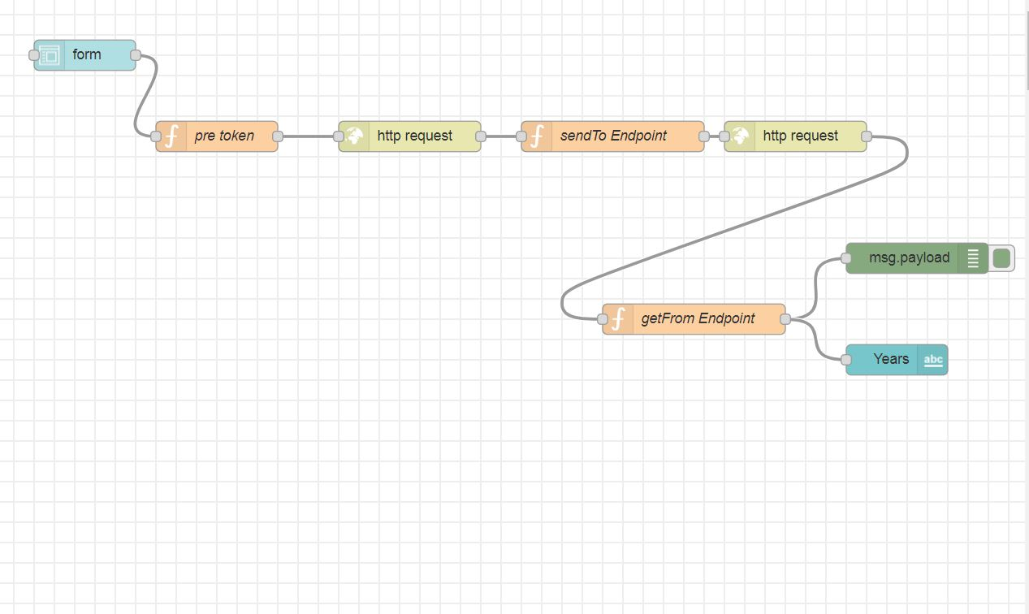

FLOWCHART-2:LIFE EXPECTANCY WITHOUT PYTHON

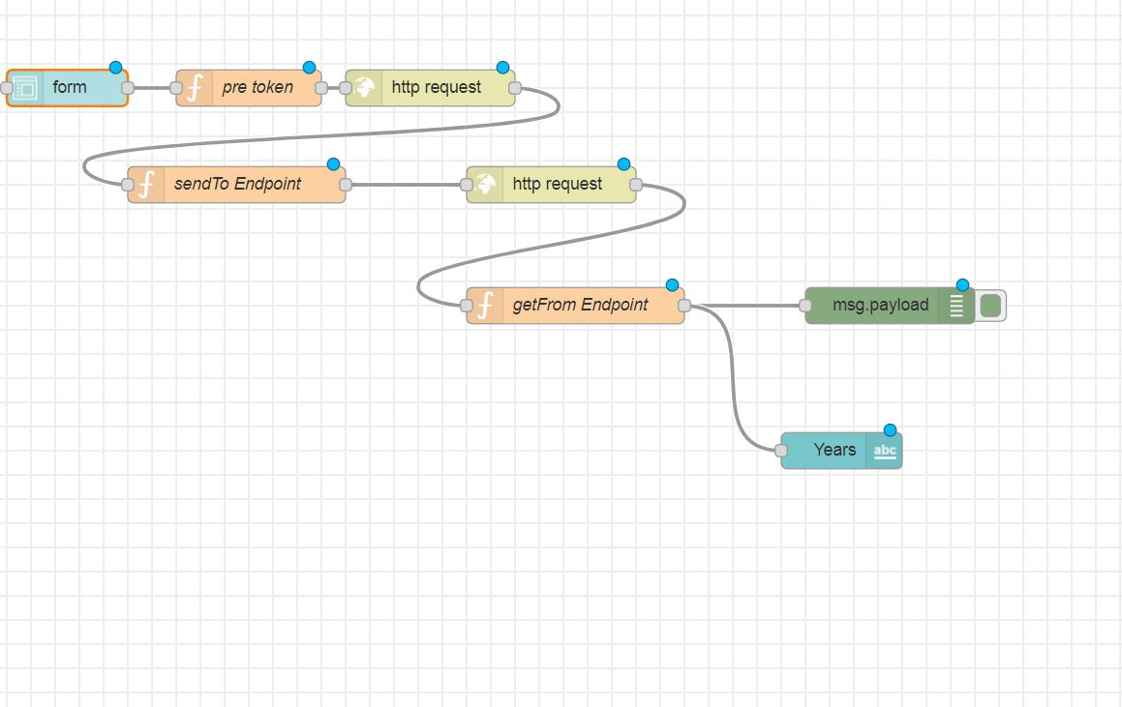

**RESULT:**

**1.PREDICTING LIFE EXPECTANCY WITH PYTHON**

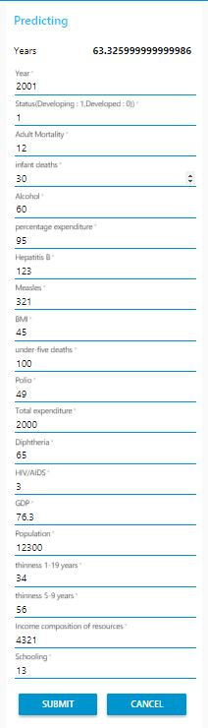

This machine learning model result is regarding predicting the life expectancy with python.Here the user needs to enter the inputs in each column and according to the inputs given the output will be displayed i.e the life expectancy will be displayed at the top of the page.According to my inputs given life expectancy is 63.325999999999986 years.

**2.PREDICTING LIFE EXPECTANCY WITHOUT PYTHON**

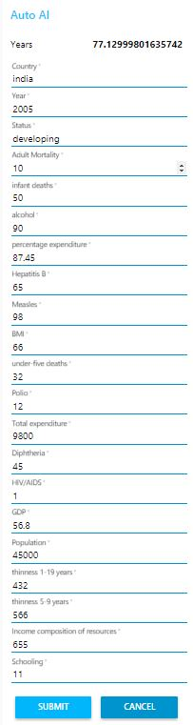  
**ADVANTAGES AND DISADVANTAGES:**

This machine learning model result is regarding predicting the life expectancy without using python.Here the user needs to enter the inputs in each column and according to the inputs given the output will be displayed i.e the life expectancy will be displayed at the top of the page.According to my inputs given life expectancy is 77.12999801635742 years.

● Machine Learning can review large volumes of data and discover specific trends andpatterns that would not be apparent to humans and thereby increasing the accuracy in

prediction.

● We can create a user interface easily with help of Node-RED and give the input to the model and predicts the Life expectancy.

● Countries or people may get to know of features they should focus on to improve the life expectancy of a person.

● Machine Learning requires massive data sets to train on, and these should be inclusive/unbiased, and of good quality. There can also be times where they must wait for new data to be generated.

● ML needs time to let the algorithms learn and develop enough to fulfill their purpose with a considerable amount of accuracy and relevancy. It also needs massive resources to function. This can mean additional requirements of computer power.

**APPLICATIONS**

Life expectancy is the primary factor in determining an

individual's risk factor and the likelihood they will make a

claim. Insurance companies consider age, lifestyle choices

and several other factors when determining premium rates

for individual life insurance policies. It can be used by

researchers to make meaningful researches out of it and

thus, bring about something that will help increase the

expectancy consider the impact of a specific factor on the

average lifespan of people in a specific country.

**CONCLUSION**

We have developed a machine learning model that will predict the life expectancy of a specific demographic region based on the inputs provided by the user. Various factors have a significant impact on the life span such as Adult Mortality, Population, Under 5 Deaths, Thinness 1-5 Years, Alcohol, HIV, Hepatitis B, GDP, Percentage Expenditure and many more.

User can interact with the system via a simple user

interface which is in the form of a form with input spaces

which the user needs to fill the inputs into.

**FUTURE SCOPE**

We can connect this machine learning model to the database

to have the record of predictions. This will help us analyze

the trends in the life span. A model with country wise

bifurcation can be made, which will help to segregate the

data demographically.

**SOURCE CODE:**